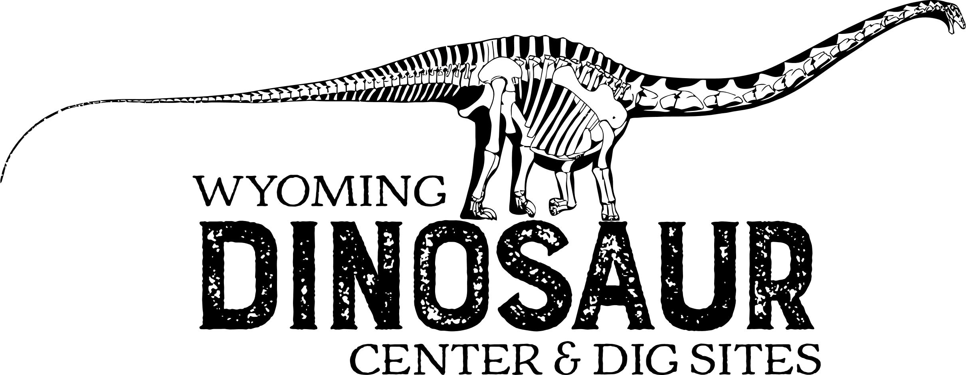
Wyoming Dinosaur Center
110 Carter Ranch Road
P.O. Box 351
Thermopolis, WY 82443
Ph: 307-864-2997 - Fax: 307-864-5762
A 501(c)3 Non-Profit Education Corporation

Teacher’s Workshop Application Form

Name:
Address:
City: _______________________________ State: __________________ Zip: ______________
Email:
Telephone: ____________________________________________________________________
Date of Preferred Program: _______________________________________________________

School currently working at:
*If not currently teaching, list your most recent position.
Grade(s)/Age Level(s) Teaching:
Subject(s) Teaching:
Years Teaching:
Highest level of education:

Why do you want to participate in this program?

How do you think that this program will benefit you and your students?

How do you plan to integrate what you learn on this program into your curriculum?

Have you participated in any other programs like this one?

Additional information you may want to share with us:

