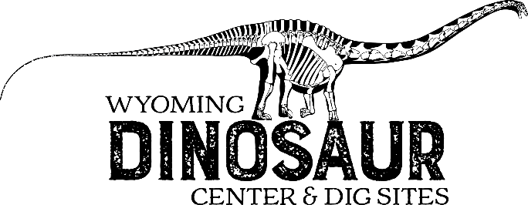
Scavenger Hunt: High School Edition
Hints:
- If you follow the exhibits in order, it will be easier to find the answers.
- MYA/mya = millions of years ago.
- In the questions themselves, you will find more hints as to which exhibits will help you.
Ready—Set—Search!
- Draw and label the four layers of the Earth with thicknesses of each layer.
Word bank: inner core, crust, outer core, mantle

- When did Earth’s magnetic field form and what importance did that have for life on Earth?
________________________________________________________________________________________________________________________________________________________________________________________________________________________________________________________________________________________________
Precambrian Era
- Complete the chart to show why stromatolites were important in the Precambrian.

Stromatolites
Bacteria + Algae

- What is the Ediacaran fauna?
________________________________________________________________________________________________________________________________________________________________________________________________________________________
Cambrian Period
- Trilobites were some of the first animals with hard body parts What is the family of organisms containing modern horseshoe crabs, crayfish and the extinct Trilobite?
________________________________________________________________________
Mollusca
- Find the “heteromorph” ammonites. What do you think might be a possible reason for these odd shapes?
________________________________________________________________________________________________________________________________________________________________________________________________________________________
Echinoderms
- Are Crinoids Plants or animals?______________________________________________
- List 3 modern echinoderms.
________________________________________________________________________________________________________________________________________________
Origin of Chordates
- What body part did the first vertebrates have that no other animal had developed yet?
________________________________________________________________________
- What defense mechanism did early fish develop to protect themselves from the large invertebrate predators? And what did they sacrifice in the process?
________________________________________________________________________
________________________________________________________________________
Sharks
- Look at the fossilized “white” shark. How did this animal get fossilized and what distinct characteristic of sharks might make their fossils hard to preserve and find?
________________________________________________________________________________________________________________________________________________
Placoderms
- Many fish developed during this time. These early fish of the Devonian Period developed some new body parts that allowed them to become better predators. What adaptation would allow them to eat larger and more heavily armored fish prey?
________________________________________________________________________
- Name the three main types of fish on display. (Hint: look for differences in their bones.)
  - _______________________________
  - _______________________________
  - _______________________________
Actinopterygians
- Name one adaptation that made the Actinopterygians more successful than the Placoderms?
________________________________________________________________________

Sarcopterygians
- Find the Coelacanth, this is a lobe-finned fish that has remained almost exactly the same for the past 70 million years. However, some of the lobe finned fishes kept evolving. Some developed into a entirely new group of animals that were no longer fish. What was the name of this new group of animals?
________________________________________________________________________
Was Ichthyostega one of this type of animal?____________________________________
- This new group of animals could go somewhere that no vertebrates had gone before (Invertebrates and plants had beaten them there though). Where did they go?
____________________________________
- Fill in the cladogram below with animals you have previously learned about in the museum.
Amphibians

Actinopterygians

Sharks

Vertebrates

- Why did some fish in the Carboniferous have fingers? What did they use them for?
________________________________________________________________________________________________________________________________________________
Proto-mammals
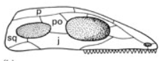
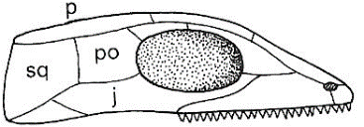
- Label the 3 skull types below. As you are going through the museum, identify one animal example for each skull type.
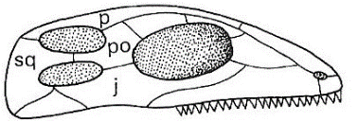

____________________ _____________________ _____________________
Ex:____________________ Ex:_____________________ Ex:_____________________
Pterosaurs
- Observe the Pterosaurs, (there are many throughout the museum, don’t forget to look up!) Are these animals dinosaurs?________________________________________________
What makes their wings different from other animals’ wings?
________________________________________________________________________________________________________________________________________________________________________________________________________________________
The Triassic Transition
- Find the Mesosaurus. Their fossils have been found in both Africa and South America. How could they be found on two continents separated by an ocean?
________________________________________________________________________
________________________________________________________________________________________________________________________________________________
Dinosaurs
- Use the diagram in the Hip Divisions case to determine what group this dinosaur belongs to. Bonus if you can identify the dinosaur by name.

________________________________________________________________________

- Find the Archaeopteryx (Head into the main gallery and turn right).
Do you think it is a Reptile, Bird, or Dinosaur? (circle your choice)
List some traits make this animal difficult to place in only one group?
  - ________________________________
  - ________________________________
  - ________________________________
  - ________________________________
- Find the horseshoe crab trackway. This fossil and the archaeopteryx were both found in the Solnhofen Limestone of Germany. Why do you think all of the Solnhofen fossils are so well preserved?_________________________________________________________
________________________________________________________________________________________________________________________________________________

- Find the Camarasaurus and the Supersaurus. How are they different, and how are they alike? Look at the limb length proportions as well as differences in their skulls.
________________________________________________________________________________________________________________________________________________

- Not all animals that lived in the Triassic, Jurassic, and Cretaceous were dinosaurs. Find and name 2 animals in the main hall that were not dinosaurs.
- __________________________________________________________________
- __________________________________________________________________
- Find the Stenopterygius. Why is this marine reptile important? Look closely, do you think this specimen is a male or female? What brought you to that conclusion?
________________________________________________________________________________________________________________________________________________________________________________________________________________________

- Find the Maiasaura. This dinosaurs name means “good mother lizard.” Why did scientists give it that name?__________________________________________________________
________________________________________________________________________

- Find two dinosaurs that have neck frills similar to Triceratops horridus and name them.
- __________________________________
- __________________________________
What do you think they used the neck frills for?
________________________________________________________________________

- Find the Tyrannosaurus rex and the Allosaurus fragilis. Study their skeletons including he skulls and teeth. Now, describe and compare the two.
 | T. rex | A. fragilis
Skull
Teeth
Arms
Body
- There are two dinosaurs with bony plates and spiked tails in the museum. (Hint: one is being eaten by the Allosaurus, the other is by the Velociraptors.) Name them and describe one notable difference between the two species.
________________________________________________________________________________________________________________________________________________

- List one possible uses, Stegosaurus might have for the plates on its back.
________________________________________________________________________
Pathology and Taphonomy
- Can dinosaurs get hurt? Find one injury/condition that you can see in dinosaurs and modern animals/humans and describe it here.
________________________________________________________________________________________________________________________________________________
Mammals
- Find the food cache.
What animals are preserved here?_____________________________________________
What are these fossils missing?_______________________________________________
What animal likely created this cache?_________________________________________
Meteors
- There are several theories as to why the dinosaurs died out. One of those is an asteroid impact. After the asteroid enters the atmosphere, it breaks up into smaller pieces of rock. Some of these smaller pieces land on earth. These are called meteorites. What are the three types of meteorites?
________________________________________________________________________
- When a meteorite enters the Earth’s atmosphere, it may produce a colored streak of light. What element is present if the streak of light is Blue-green?
___________________________________
Bonus: We have two Velociraptors on display in the museum. Can you tell what Jurassic Park/World got wrong about this animal? What animal did they actually base their model off of?

