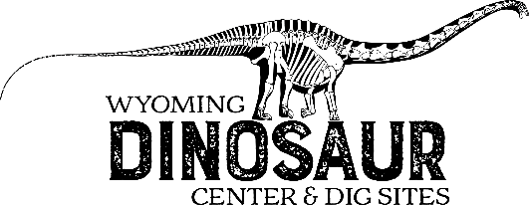
Scavenger Hunt: 7th-8th Grade
Hints:
- If you follow the exhibits in order, it will be easier to find the answers.
- MYA/mya = millions of years ago.
Ready—Set—Go!
- How old is the Earth? ____________________________________________________________
- Identify the 9 main tectonic plates on the map below by drawing in the boundaries and labeling each.
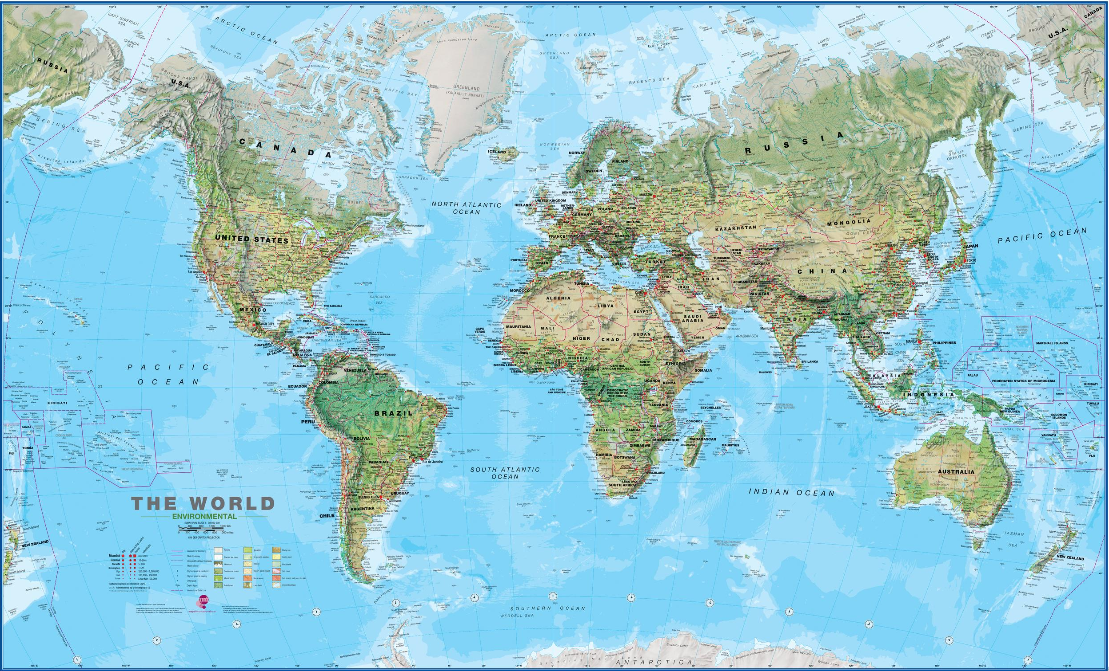
- Following the Cosmic Calendar, on what day did
the Milky Way Galaxy form? ______________________________________________________
Multicellular Life appear? ________________________________________________________
Pangea break apart? _____________________________________________________________
- Stromatolites contain the earliest life on Earth! How old are the earliest traces of life?
______________________________________________________________________________
- Arthropods are a large, diverse group of animals. Name some examples of extinct arthropods:
- ___________________________________________________
- ___________________________________________________
Name some Modern Arthropods:
- ___________________________________________________
- ___________________________________________________
- How many lenses can trilobites have in their eyes? ______________________________________
- Find the bright red ammonite with a distinct bite mark on it, what do scientists think bit this ammonite? ____________________________________________________________________
- What fossils in the echinoderm case come from Indiana? _________________________________
- List three traits of a chordate.
1.____________________________________________________________________________
2. ____________________________________________________________________________
3. ____________________________________________________________________________
- Draw 3 different shark teeth.

- Why are you more likely to find shark teeth fossilized than other parts of the body?
____________________________________________________________________________________________________________________________________________________________
- Find 1 difference between Dunkleosteus and Titanicthys:
______________________________________________________________________________
- Early lobe finned fish were transitional animals. Their fins transitioned to limbs. Count the number of fingers and toes for the following animals:
 | Fingers | Toes
Acanthostega
Greererpeton
Captohinus
What purpose do you think fingers served in early fish?
____________________________________________________________________________________________________________________________________________________________
- Find the Dimetrodon. What type of animal was this? When did it live?
Type:__________________________________Age:___________________________________
- What three things make “Lori” so important to the WDC?
1. ____________________________________________________________________________
2. ____________________________________________________________________________
3. ____________________________________________________________________________
- Archaeopteryx is known as a transitional fossil between dinosaurs and birds. List 3 dinosaur traits and 3 bird traits of Archaeopteryx.
 | Dinosaur Traits | Bird Traits
1.
2.
3.

- Find the horseshoe crab trackway and look up. What type of animals are these? Do you think they are dinosaurs? __________________________________________________________________
- What is Jimbo’s Scientific name? ___________________________________________________
- How many Ceratopsians (dinosaurs with horns/frills) do we have in the museum? _____________
Name two of them in the space below:
- _________________________________________________________
- _________________________________________________________
- Look at the Tyrannosaurus rex and the Allosaurus fragilis and compare the two.
 | T. rex | A. fragilis
Teeth
Skull
Arms
Size

- When did Dinosaurs go Extinct? ____________________________________________________
- There are several theories as to why the dinosaurs died out. One of those is an asteroid impact. After the asteroid enters the atmosphere, it breaks up into smaller pieces of rock. Some of these smaller pieces land on earth. These are called meteorites. What are the three types of meteorites?

  - ____________________________________________________
  - ____________________________________________________
  - ____________________________________________________

