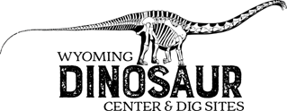

Scavenger Hunt: 4th-6th Grade

Can You Find....? All of these answers are easier to find if you follow the museum’s timeline!

How old is the earth?

What State are the Eurypterids (Sea Scorpions) from?

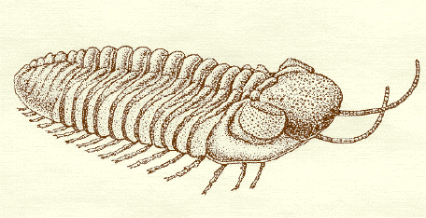
Do you see any fossils that look like roly-polys?
What are they called?
(Hint: One whole cabinet is only fossils of these little arthropods.)

Find the Trilobite Mass Death and count how many trilobites you see. Why do you think they all died together?

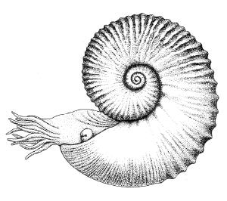
Can you find an Ammonite?
It has a shell that’s spiraled tight,
With lots of tiny tentacles,
And very good eyesight,
Surely it gave its prey a fright!
What animal that is still alive does an ammonite look like?

(Hint: What animals do you know with tentacles?)

What do crinoids look like to you?

Are crinoids plants or animals?
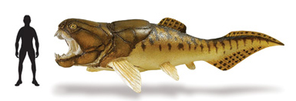

This ancient fish has no teeth
That doesn’t stop this terror of the deep.
With Stronger jaws than any other,
It cuts through anything like butter!
Can you find the Dunkleosteus?
 1 Dunkelosteus
Is the coelacanth model longer than you are tall?  Yes  No
Write down the name of a mammal-like reptile with tusks or fangs!
You might think I’m a dinosaur, But I’m a mammal ancestor! Can you find me?

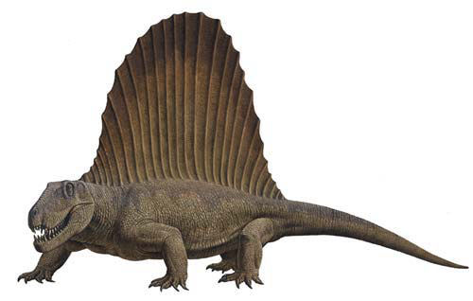 Found 1 Dimetrodon

I am the Wyoming Dinosaur Center’s newest addition, what is my nickname?

I spy a bird with teeth! No, wait, a dinosaur with feathers! It has a big claw like a raptor but wings like a bird! What is its name?
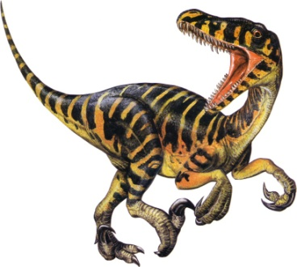

How many Velociraptors can you find? _________
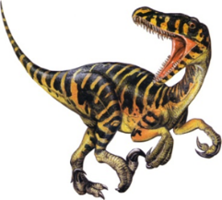

Write down the name of an animal hanging from the ceiling.

Find the Morticional (Death) Trackway. What animal is at the end of the trackway?

What marine reptile has a neck longer than its tail?

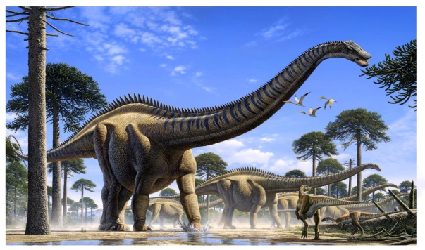
I am a sauropod named for my super size.
Check out my 9.5 foot long rib!
Who am I?
Scientific:

Nickname:

This predator has two crests above its eyes and is chewing on a Stegosaurus. Since it’s a predator, you know it must have sharp teeth and claws. What is its name?

Not all Dinosaurs are vicious, my name means “Good Mother Lizard,” you can see me taking care of a nest of my babies. What is my scientific name?

Write down the name of a dinosaur you see that is smaller than a horse.
(There are many to choose from).

My name means “3 horn face” I am also the Wyoming state dinosaur. Who am I?

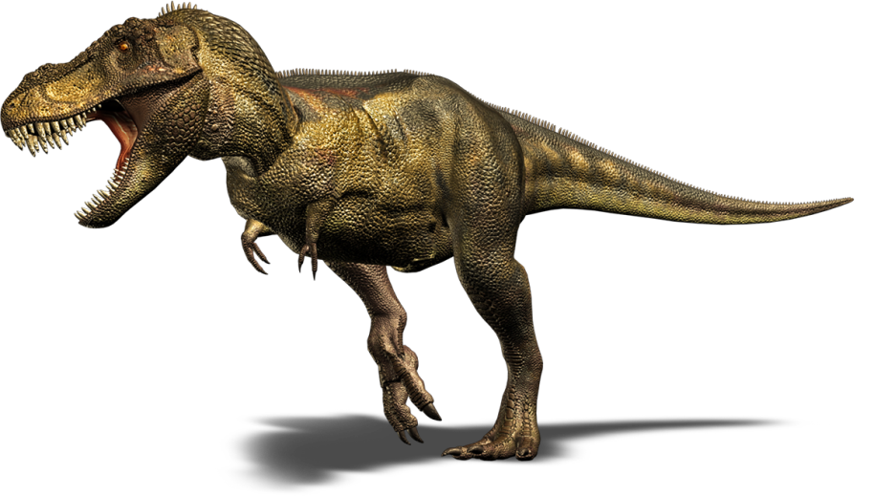

How many teeth does Stan the T-Rex have?

What dinosaur here would you want as a pet?

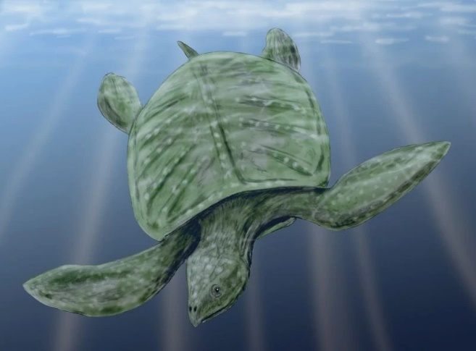
Find the giant turtle sitting above you. What is his name? _______________________________

Where do you think Archelon lived? (ocean, land,
river, etc.) _________________________________

