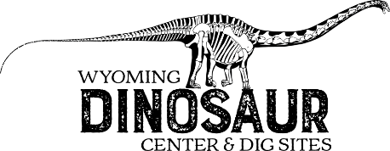
FOSSIL HUNT: 2nd-3rd Grade

WHAT IS THE OUTERMOST LAYER OF THE EARTH CALLED?
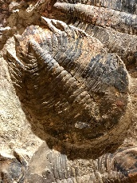
__________________________________________________

I AM A TRILOBITE, WHAT IS MY NAME?

____________________________________________

FIND THE AMMONITE YOU CAN TOUCH. HOW OLD IS IT? _____________________________________
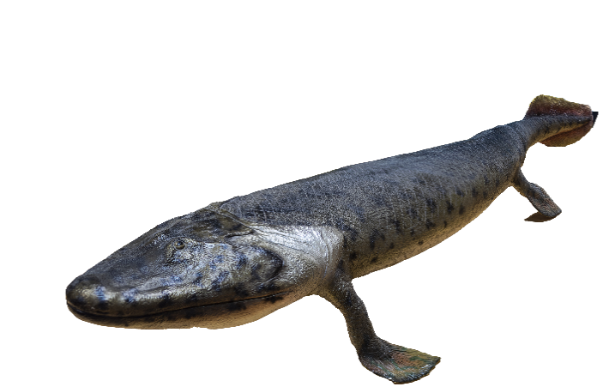
FIND THE BRITTLE STAR PARTY BEHIND YOU. HOW MANY STARS CAN YOU COUNT? ________________________________________________

I’M A FISH THAT CAN DO A PUSH-UP.
WHAT IS MY NAME?

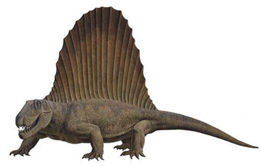
_____________________________________________

FIND THE DIMETRODON. AM I A DINOSAUR?
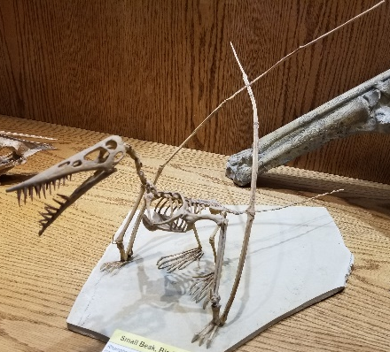
YES NO

FIND THE RHAMPHORHYNCHUS WHAT DO YOU THINK I ATE? _________________________________________
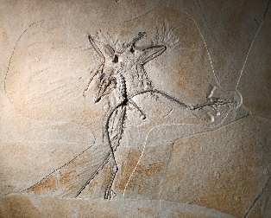
FIND THE ARCHAEOPTERYX. WHERE WAS THIS FOSSIL FOUND?
____________________________________________
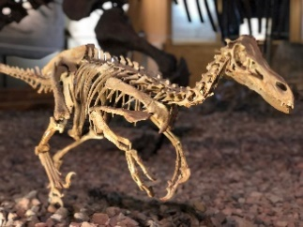
HOW MANY VELOCIRAPTORS ARE ON DISPAY?

____________________________________________

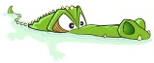
FIND A CROCODILE IN THE MUSEUM. NAME ONE:
____________________________________________________________

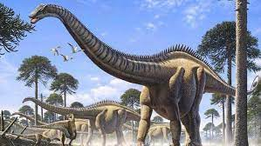
HOW LONG IS JIMBO the Supersaurus:

________________FEET
________________METERS

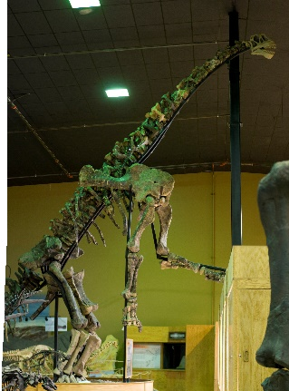

I AM STANDING UP ON MY HIND LEGS TO REACH AN INVISIBLE TREE. WHAT AM I?
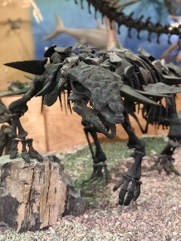
__________________________________

I HAVE ARMOR PLATES ON MY BACK AND SIDES.
WHAT AM I?
____________________________________________

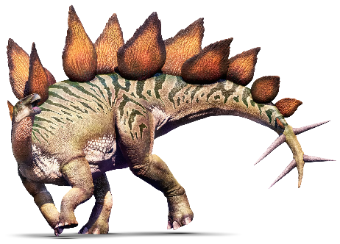
FIND THE STEGOSAURUS BEING ATTACKED!
HOW MANY PLATES ARE ON THE STEGOSAURS BACK: ______________________________
FIND THE MAIASAURS, COUNT THE NUMBER OF BABIES IN THE NEST: ____________________________________________________________

FIND THE T. REX AND TRICERATOPS. ONE OF THESE IS THE WYOMING STATE DINOSAUR. WHICH ONE DO YOU THINK IT IS?
_____________________________________________________________
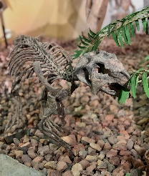
WHAT IS THIS SMALL DINOSAUR’S NAME?

_____________________________________

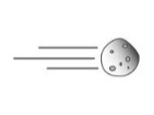WHAT KILLED THE DINOSAURS? ___________________________

HOW MANY METEORS ARE IN THE MUSEUM ON DISPLAY? ___________

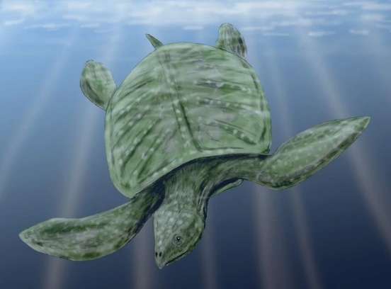
CAN YOU FIND A GIANT TURTLE?
WHAT IS ITS NAME?
______________________________________

